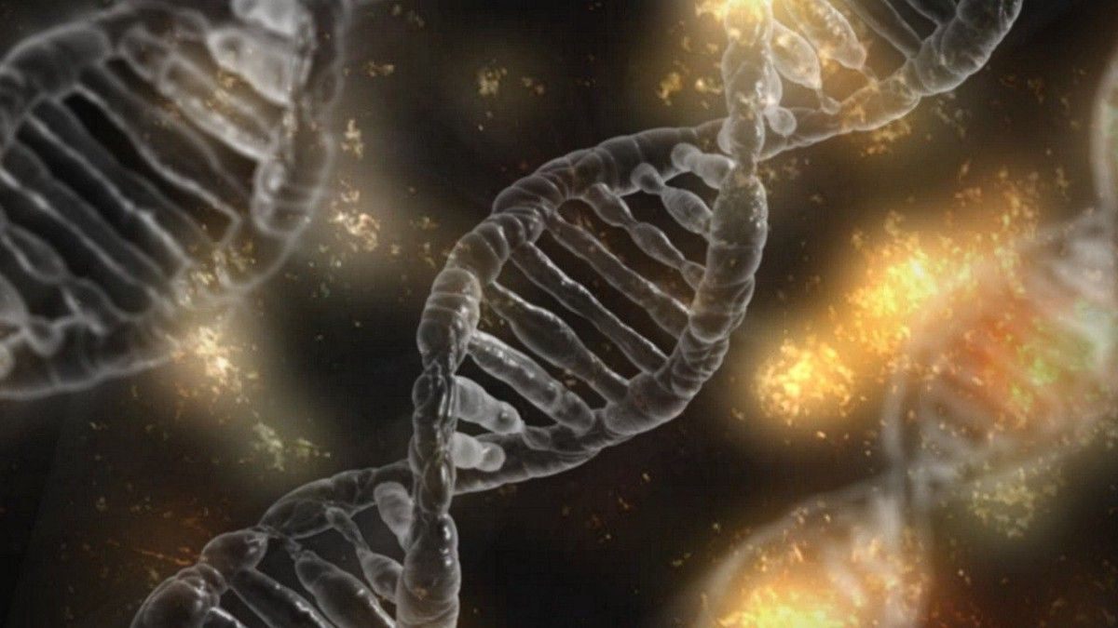

Travel Salesman Problem

**The Travelling Salesman Problem (TSP) is the most comprehensively studied problems and widely used in computational mathematics, operations research, and computer science. Precisely, TSP states a salesman and n cities defined as a route on an undirected graph where the core objective is to find the shortest possible way that a salesman should travel across a number of cities and returns to the original city with minimum distance and minimum cost. Hence, this program belongs to the class of optimization problems.

There have been multiple types of approaches to solving the TSP. The approach includes Heuristic approaches, Ant colony optimizations, Simulated annealing, Genetic algorithms, Neural networks and several other methods for more specific variations of the TSP. In this article, I’m using a genetic algorithm for the TSP.

**Overview of Genetic Algorithm (GA)**

The genetic algorithms (GA) are an optimization and search technique which is based on the same idea as Darwin’s theory of evolution. This algorithm starts with a population of individuals that have been generated randomly. The fittest individual in the population are selected for reproduction in order to produce new offspring (children) of the next generation.

**Working principle of Genetic Algorithm (GA):**

Before getting into a genetic algorithm (GA), it is necessary to explain a few terms:

* Gene: - It is a part of a chromosome. A gene contains a part of a solution. E.g. 15837 is a chromosome and 1,5,8,3, and 7 are its genes.
* Chromosome: - A set of genes; a chromosome contains the solution in the form of genes.
* Individual: - same as a chromosome.
* Population: - Number of individuals present with the same length of a chromosome.
* Fitness: - The value assigned to an individual based on how far or close an individual is from the solution; higher the fitness value, the more optimal that solution is.
* Fitness Function: - It assigns fitness value to the individual. Also, it is a problem specific.
* Mating Pool: - The individuals in the mating pool are called parents. It is a collection of every two parents from the mating pool that are used to create next population.
* Mutation: - Change a random gene in an individual.
* Selection: - Selecting individuals for mating between each other and create new offspring (Children).

**Flow Chart of** **Genetic Algorithm (GA):**



**Initial Population**: -

Genetic algorithm (GA) works on a population which is consist of some solutions where the population size is the number of solutions. Each solution is called an individual. Each individual is a set of variables which is known as genes. Furthermore, genes are joined into a string to form a chromosome where each gene in the chromosome represented by binary value, i.e. 1’s and 0’s. The group of chromosome make up a population.



**Fitness Function: -**

The fitness function defined a function to know how fit an individual is or how better the solution through the problem in consideration. This function provides a fitness score of each individual. Furthermore, individuals with low fitness values are not selected for reproduction; instead, individuals with high fitness values are taken and reproduced. Therefore, the higher its fitness value, the more optimal that solution is.

**Selection: -**

Selection is the process of selecting individuals to mate and recombine with each other to create new offspring (children) for the next generation. In addition to this, the chances of being selected for reproduction is directly proportional to the individual’s fitness function.

Roulette Wheel: - In roulette wheel, the circular wheel is divided into n pieces where n is represented as a number of individuals in the population. Each individual get’s a portion of the circle, which is proportional to its fitness value. Also, this strategy follows a random principle, but fitter individuals have higher probabilities of being selected.

Tournament Selection: - In this strategy, the algorithm first selects a few individuals from the population at random and then selects the fittest individual. The similar process is repeated for selecting the next individual.

**Crossover: -**

Crossover is the most significant phase in a genetic algorithm. In this step, new offspring (children) are generated, which will replace the least individuals in the population. The concept behind crossing over individuals is that, by combining different genes several times, it might produce even fitter individuals in this way, new offspring are generated.

**One Point Crossover: -**

One-point crossover is the process of mating between the two selected individuals; the process represents how genes are swapped to get new offspring.



**Two-Point Crossover:** The two points of crossover genes can be split along these lines and then recombined to produce new offspring of the next generation.



**Mutation: -**

Mutation can be defined as a small random tweak in the chromosome, to get a new offspring.

Flip bit mutation: - In flip bit mutation, the value space of each gene have just two values 0 and 1, them flip the bit value of one or more genes.



**Swap Mutation: -**

In swap mutation, select two positions on the chromosome at random, and interchange the values. This is common in permutation based encodings.

